**# DSA (Collection Framework)**

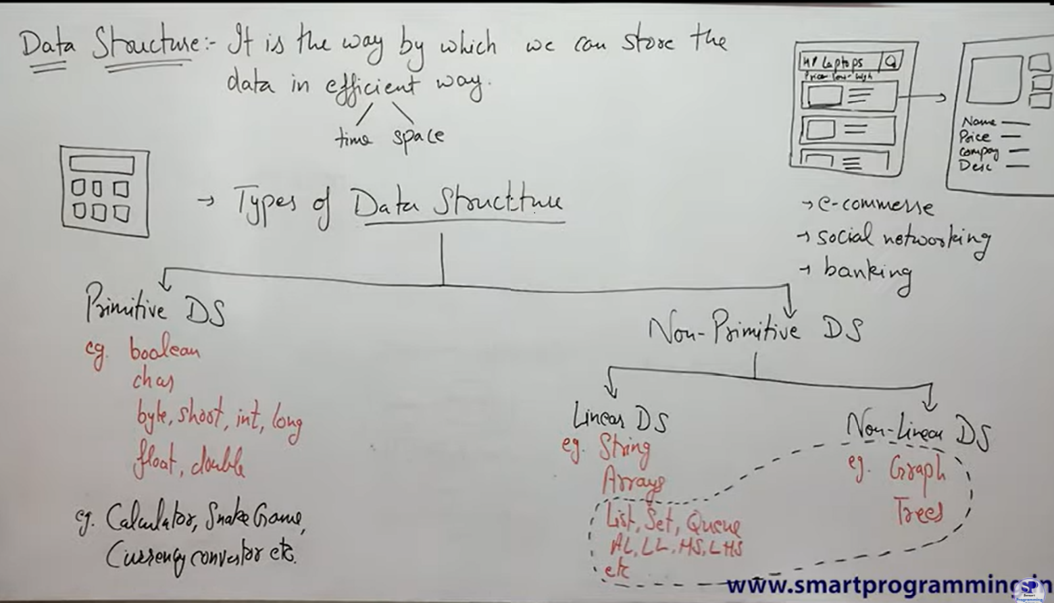# Basic classification of data structure

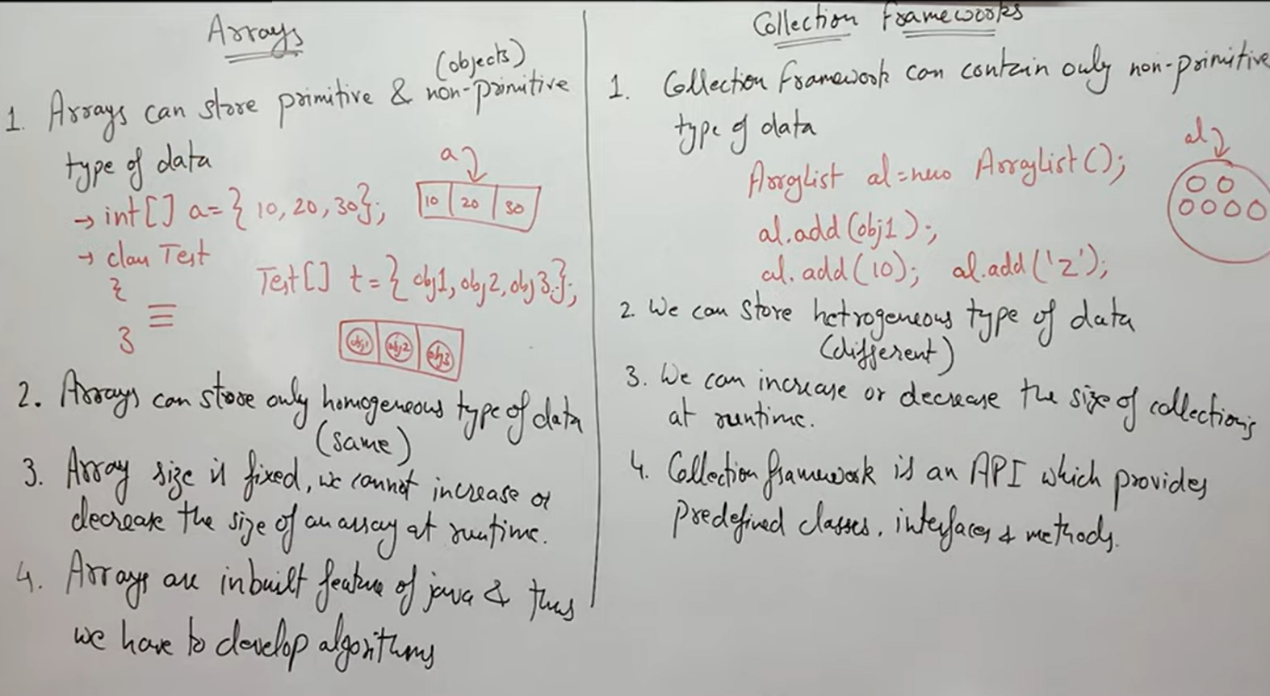 # Difference between array and collection

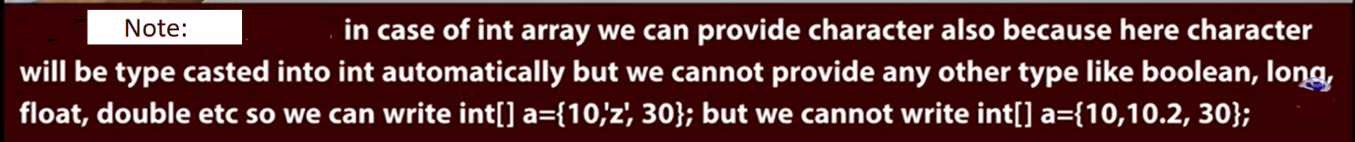

**Note:** Collection freamwork store non-primitive type of data. As we know every primitive data type(int, char, long…) have their rapper class. So if we provide primitive values in collection, it will store it like an object with the help of wrapper class.

